Project Design Phase
Solution Architecture

Date | 27 June 2026
Team ID
Project Name | Book a Doctor – Online Doctor Appointment Booking System
Maximum Marks | 4 Marks

Solution Architecture
The Book a Doctor – Online Doctor Appointment Booking System is a web-based healthcare application developed using the MERN Stack (MongoDB, Express.js, React.js, and Node.js). The system provides separate modules for Patients, Doctors, and Administrators.
- Patients can register, log in, search for doctors based on specialization, book appointments, manage their profiles, and view appointment history.
- Doctors can log in, manage their profiles, view appointment requests, accept or reject appointments, and update their availability.
- Administrators can manage patients, doctors, appointments, and monitor the overall system through an admin dashboard.
The frontend is built using React.js, providing a responsive and user-friendly interface. The backend is developed with Node.js and Express.js, exposing secure REST APIs for communication between the client and server. MongoDB stores user, doctor, and appointment information. User authentication is implemented using JWT (JSON Web Token) and passwords are securely encrypted using bcrypt.
Example - Solution Architecture Diagram:
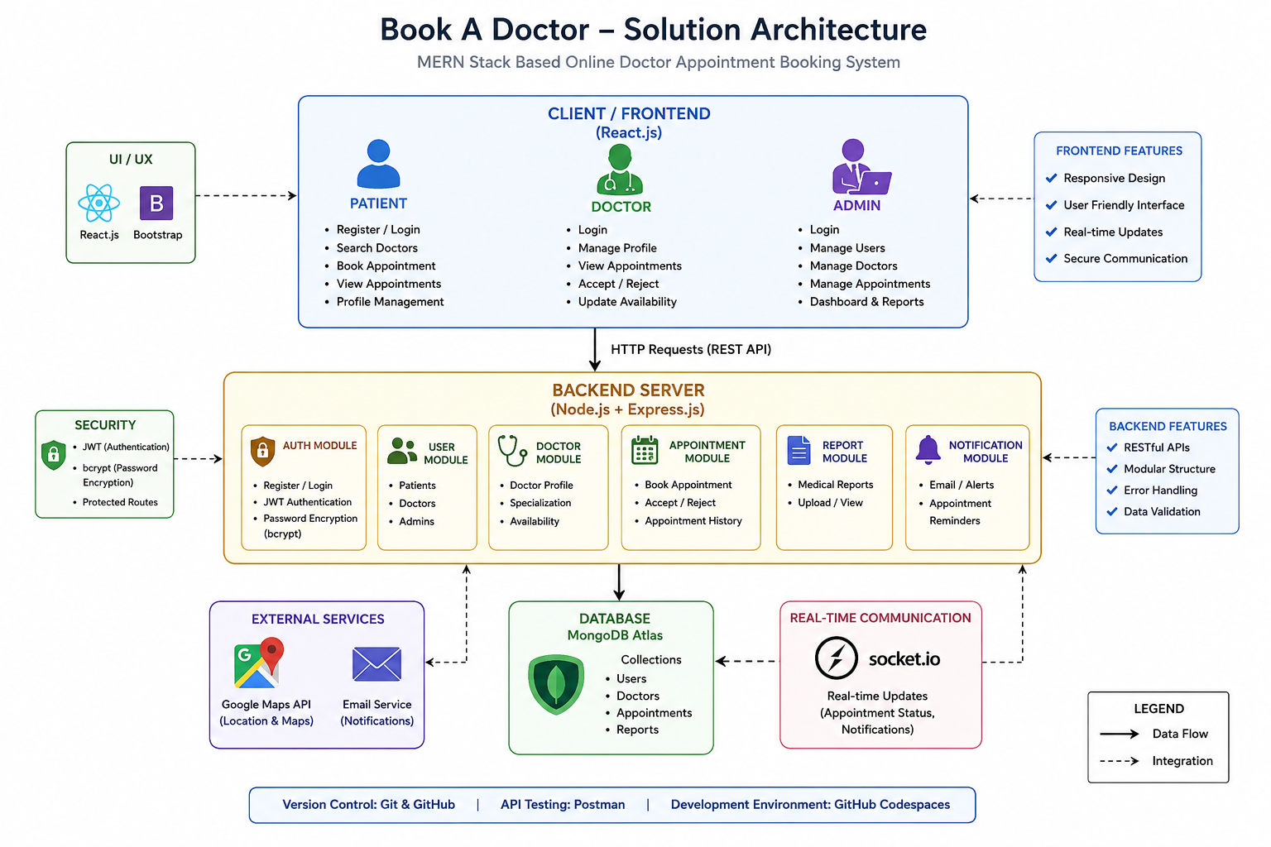

Technologies Used :
- Frontend: React.js, Bootstrap

- Backend: Node.js, Express.js

- Database: MongoDB

- Authentication: JWT & bcrypt

- Real-Time Communication: Socket.IO

- Maps: Google Maps API

- Version Control: Git & GitHub

